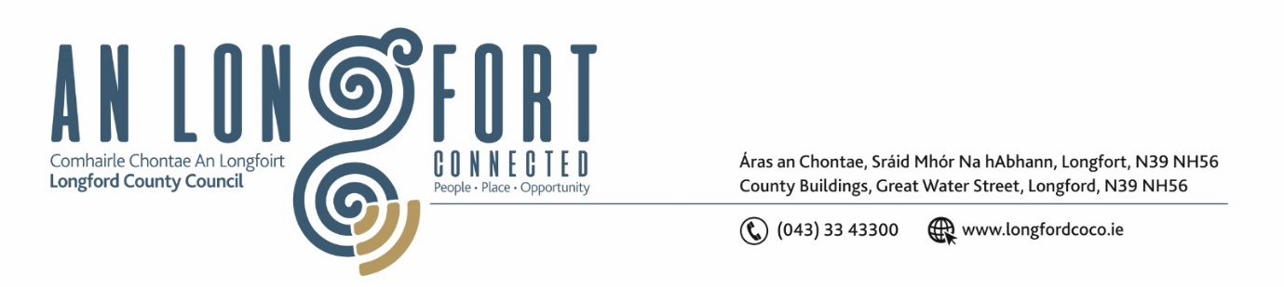

**LONGFORD MUNICIPAL DISTRICT**

***Please note meeting will be held in the Council Chamber, Aras an Chontae and via Microsoft Teams***

**15 October 2024**

**To: Each Member of Longford Municipal District.**

**Dear Member,**

You are requested to attend the Meeting of Longford Municipal District to be held in **the Council Chamber, Aras an Chontae** and **via Microsoft Teams** on **Tuesday, 22 October 2024 at 11 am** to transact business, as set out on the agenda hereunder.

**Yours sincerely**,

_______________

**Claire McNabola**

**Meetings Administrator**

**AGENDA**

Prayer before meeting.

1. Consideration of General Municipal Allocation 2025
2. Multi-Annual (3-year) Restoration Improvement Programme